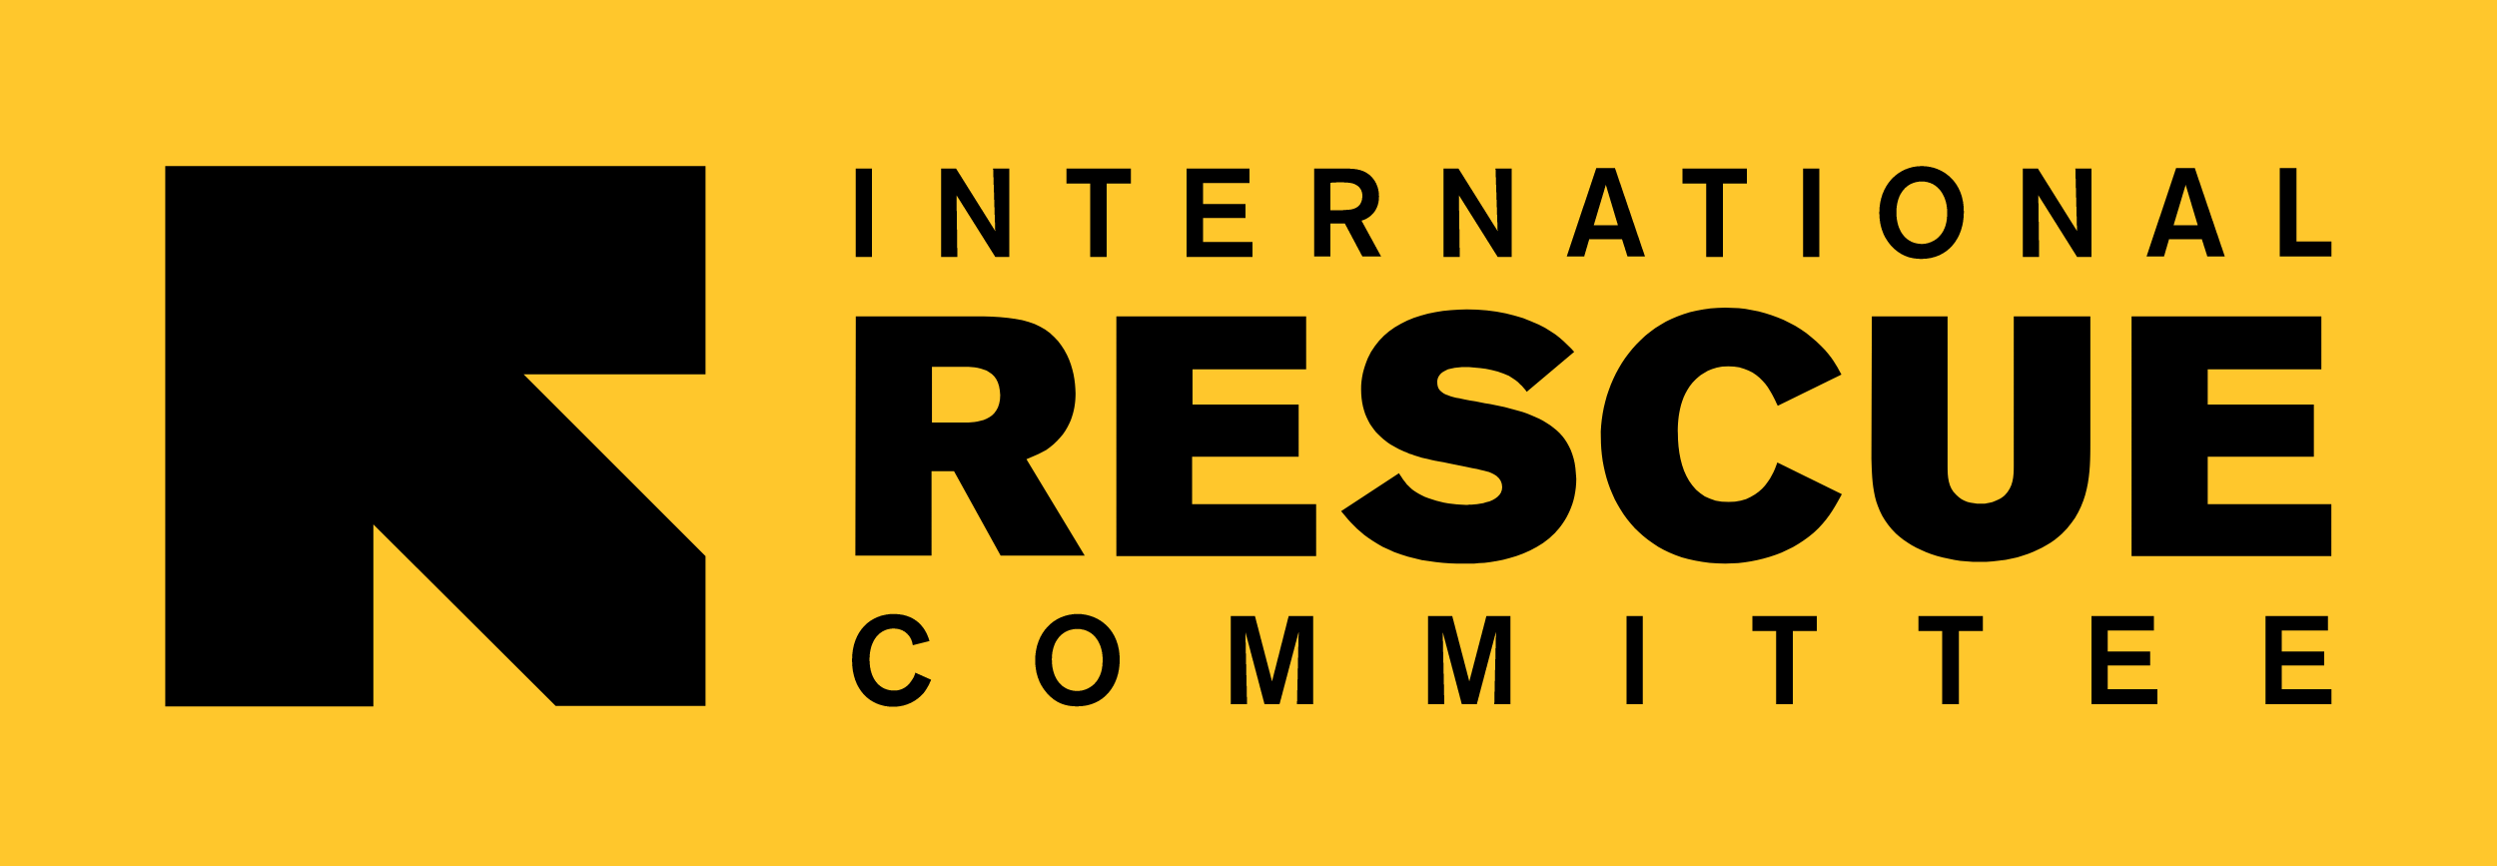

Caring for Child Survivors of Sexual Abuse (CCS) Resource Package (2nd Edition)

CCS Translation SOP

Preliminary Note

The CCS Resource Package is a global technical guidance, open for the use of any organization or entity involved in proving care for child survivors of sexual abuse. If you are interested in translating the CCS Guidelines, Training and/or e-Learning, please consider that others may already be translating (or planning to translate) the resources in the same language(s). Please write to Alexia Nisen (anisen@unicef.org) and the International Rescue Committee (VPRUMailbox@rescue.org) to check the ongoing initiatives.

Guidance for Translation

- You can select any translation company you trust - ideally with proven experience with Gender / GBV / CP terminology in humanitarian settings, recognizing this may not be possible for all languages or contexts.

- It is not rare that translation companies offer a team of two to three translators to be able to deliver faster. In this case, please raise with the selected company the need to ensure harmonization of terms and style within the team of translators. If you are not under time pressure, having one single solid translator is the safest option.

- In the translation budget of the Guidelines, you will need to account for the translation (per word) and design/lay out (per page) to insert the translated text into the exact same format as the original English version. The design cost is usually minor but needs to be accounted for.

- Before sharing the files with the selected translation company, it is recommended to agree internally on the translation of relevant technical terms to guide the translation company beforehand, ensure harmonization of terms in the document and avoid back and forth during the translation process.

- Before finalizing the translation, it is important to ensure a full review by at least one mother-tongue GBV-CP expert to proofread the documents.

- If you decide to embark on a translation as per the above guidance, please contact Alexia Nisen (anisen@unicef.org) and the International Rescue Committee (VPRUMailbox@rescue.org). We will provide you access to the CCS Resource Package text files and design files.

- Once the translation is finalized, please share a PDF version of the Guidelines, a PowerPoint/Word version of the training package and/or an Word/XLIFF version of the e-learning course with Alexia Nisen (anisen@unicef.org) and the International Rescue Committee (VPRUMailbox@rescue.org) to upload on the global sites (https://knowledge.unicef.org, https://childprotectionpractitioners.org, and https://gbvresponders.org).

- Please note that funds to support translation or design are unfortunately not available at global level.

Best of luck with the translation journey!

Feel free to reach out to Alexia Nisen (anisen@unicef.org) and the International Rescue Committee (VPRUMailbox@rescue.org) for any question or additional information.

Before engaging in providing services and support to child survivors of sexual abuse and investing in CCS, organizations and entities should carefully consider whether they have the appropriate competencies and resources to offer quality care for young and adolescent girl and boy survivors of sexual abuse to mitigate any risk of harm.
The CCS Resource Package is composed by the Guidelines, the Training Materials, and the e-Learning. Ideally, you will embark on translating all three. If funds are short, you may choose to prioritize the translation of the training package to roll it out locally. It is recommended to contextualize the global training resources to your operational context before finalizing the translation. The Guidelines and the e-Learning (that covers the basic modules 0-2) do not require contextualization prior translation and usage.

